

**School of Information Technology and Engineering**

**Artificial Intelligence ITE2010**

Under the guidance of

**Prof. SUBHASHINI R**

Assistant Professor, SITE

Submitted by

**Bhaumik Tandan (19BIT0292) Harshita Jaiswani (19BIT0296)**

**Review 1**

# Abstract

The project aim is to predict the restaurant rating based on the various factors. Online customer feedback are taken as an integral part for making a decision before purchasing any product.

Present and future generation is the journey of e-commerce platform is booming in world.

Sharing on the internet is something we usually do. Giving a review is a useful activity through which other people on the internet can find out something else and see opinions about things. The usual things reviewed by someone in the form of experiences, places, objects, and others. Give a review we usually use text to explain something that we experience with an item, place, or event that we normally experience. Customer satisfaction is an opinion between expectation and reality obtained by consumers. Giving a review is also a useful activity so that other customer on the internet can find out something else and see opinions about things and its satisfaction.

Commonly, most people express their opinion through social media on the review platform like Zomato, Yelp, etc. Customer reviews on online media like Zomato become important as it might increase the popularity of something. Zomato is a site where someone can give a review of a restaurant, how the restaurant is and someone's opinion about the restaurant. Restaurant customer satisfaction can be analysed by their review on Zomato. Sometimes, restaurants see the reviews in Zomato, but they didn’t get if the reviews are positive or negative to their restaurants. Review on Zomato is still in the form of text and can be classified with positive, negative, or neutral with their ratings.

The food chain industry is a very competitive one and lack of research and knowledge about the competition usually leads to the failure of many such enterprises. The principal issues that continue to produce difficulties to them include high real estate expenses, escalating food costs, fragmented supply chain, over-licensing, and even after that restaurateur does not know whether the business will develop or not. This project aims to solve this problem by analysing ratings, reviews, cuisines, restaurant type, demand, online ordering service, table booking, availability of the restaurant and make the machine learning model learn these and predict ratings of new restaurant and how positive and negative reviews should be expected. This project considers the data of the restaurant from all over India from Zomato as an example for showing how our model works and can help a restaurateur choose the location and cuisine which will give it better ratings, reviews, and make the business more profitable.

# Flowchart

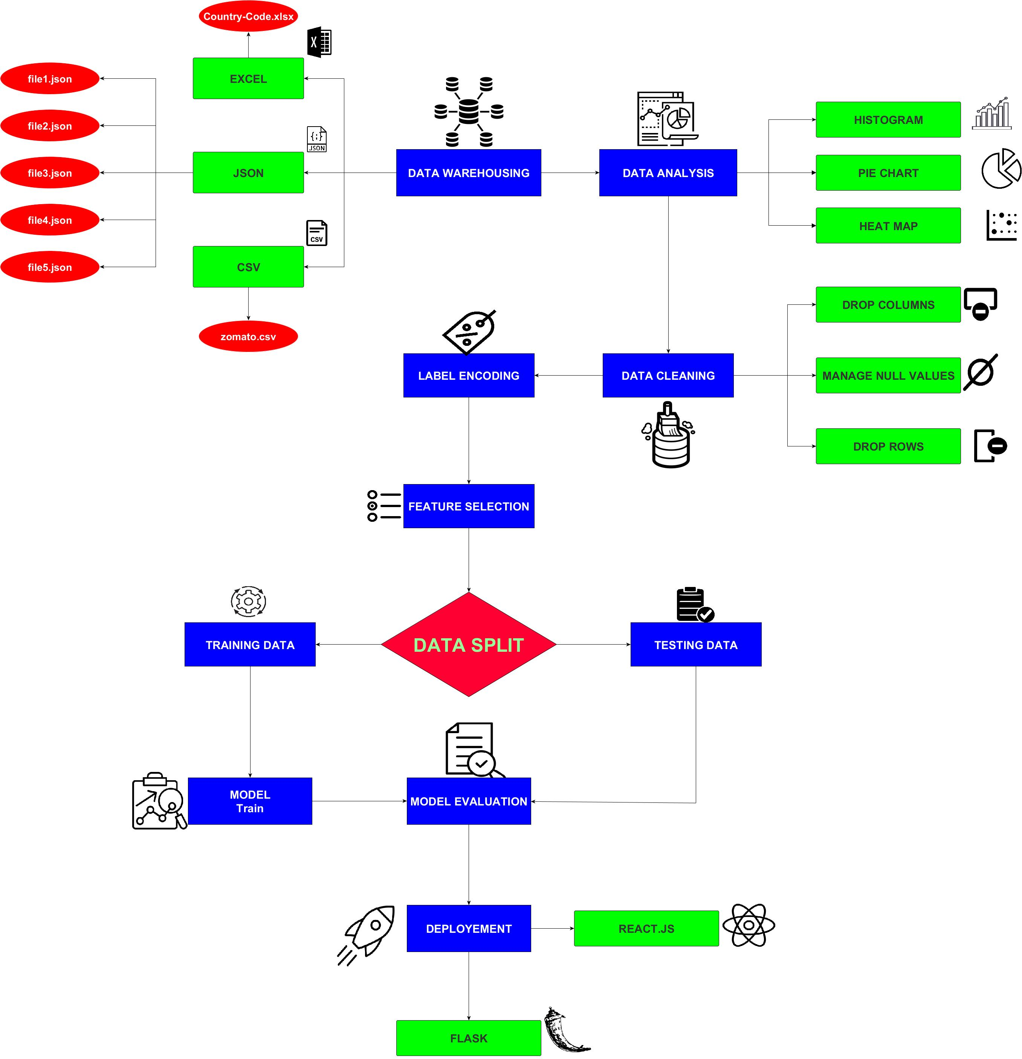

Made using yEd Graph Editor

# DATASET DESCRIPTION & SAMPLE DATA

The dataset used in the project is the Zomato Dataset. The dataset gives a fair idea about the factors affecting the establishment of different types of restaurant at different places in country aggregating the rating of each restaurant. The Dataset contains all details of the restraint listed on the Zomato website as of March 2019. The dataset contains 9554 rows with the following features:

* Restaurant Id: Unique id of every restaurant across various cities of the world
* Restaurant Name: Name of the restaurant
* Country Code: Country in which restaurant is located
* City: City in which restaurant is located
* Address: Address of the restaurant
* Locality: Location in the city
* Locality Verbose: Detailed description of the locality
* Longitude: Longitude coordinate of the restaurant's location
* Latitude: Latitude coordinate of the restaurant's location
* Cuisines: Cuisines offered by the restaurant
* Average Cost for two: Cost for two people in different currencies
* Currency: Currency of the country
* Has Table booking: yes/no
* Has Online delivery: yes/ no
* Is delivering: yes/ no
* Switch to order menu: yes/no
* Price range: range of price of food
* Aggregate Rating: Average rating out of 5
* Rating color: depending upon the average rating color
* Rating text: text on the basis of rating of rating
* Votes: Number of ratings casted by people Sample of the dataset.